**PRESIDENCY SCHOOL BANGALORE SOUTH**



**FLIGHT BOOKING SYSTEM**



**SUBJECT:COMPUTER SCIENCE**

**DONE BY:**

Nidhi Vinayak Kulkarni

**XII‘A’**

**2022-2023**

CERTIFICATE

***Name: __________________ Class: 12th ‘A’***

***Exam No: _________***

***This is certified to be the bonafide work of the student in the computer science laboratory during the academic year 2022-23.***

***__________________________ TEACHER INCHARGE***

***_______________________ ___________***

***EXAMINER’S SIGNATURE PRINCIPAL***

***Date: ______________ Institution Rubber stamp***

**ACKNOWLEDGEMENT**

*I wish to express my deep gratitude and sincere thanks to all my teachers for encouragement and the management for providing all facilities to successfully complete the project work.*

*I extend my sincere thanks to my principal, Mrs. J Bhuvaneswari and my Computer Science teacher, Mrs. Tamil Selvi whose valuable guidance helped me not only successfully complete the project but also appreciate the beauty of the computer science.*

*I extend my gratitude to my parents and classmates for their valuable support and time.*

**INDEX**

|  |  |  |
| --- | --- | --- |
| **S.No** | **Topic** | **Pg.no** |
| **1.** | **System Hardware and Software Specifications** | 5 |
| **2.** | **Project synopsis** | 6 |
| **3.** | **Design work** | 7 |
| **4.** | **Coding** | 9 |
| **5.** | **Output** | 66 |
| **6.** | **Further development area** | 70 |
| **7.** | **Bibliography** | 71 |

**SYSTEM SOFTWARE AND HARDWARE SPECIFICATIONS SOFTWARE**

***SOFTWARE***

***The software used to run the program are :***

*⮚* ***Visual Studio Code***

* ***IDLE***
* ***Windows 11,10***
* ***MySQL 5.5***

***HARDWARE***

***The hardware used to run the project are :***

* ***Dell Inspiron***
* ***HP Prodesk***

**PROJECT SYNOPSIS**

This project helps to build a interface between the airline companies and the passengers so that they can book tickets from anywhere in the world. The system should ask for the travel from and travel to cities. For booking the customers has to sign-up or sign-in and enter the passenger details. It is a simple airline railway reservation system which uses TKinter to build up a GUI and SQL database to store the signup information of a passenger. The travel from and to city should be different otherwise it would show an error. It uses different modules of TKinter to build a reservation system using button, label, message box, entry, frames and title. When the program runs, it will show a frame which asks about departure and arrival city, and if the customer  wants to book he can proceed with the sign-in and sign-up.

**DESIGN WORK**

1. **Import os:** The OS module in Python provides functions for creating and removing a directory (folder), fetching its contents, changing and identifying the current directory, etc.
2. **install():**The **install** command installs a specified file in a specific place within a file system.
3. **get():** To return the data entered in an Entry widget, we have to use get().
4. **global:** Global keyword is used to modify the global variable outside its current scope and meaning. It is used to make changes in the global variable in a local context. The keyword ‘Global’ is also used to create or declare a global variable inside a function.
5. **place():**This geometry manager organizes widgets by placing them in a specific position in the parent widget.
6. **set():**The .set() method in Python's Tkinter library is used to set the value of a Tkinter variable. Tkinter variables are objects that hold a value, and they are used to store and retrieve data in Tkinter widgets.
7. **destroy():** The destroy() method in Tkinter destroys a widget. It is useful in controlling the behavior of various widgets which depend on each other.
8. **photoImage**(): We Load the image in a variable using ImageTk.PhotoImage(file=file_location) function
9. **Label():**This widget implements a display box where you can place text or images. The text displayed by this widget can be updated at any time you want.
10. **Button():**The Button widget is used to add buttons in a Python application. These buttons can display text or images that convey the purpose of the buttons. You can attach a function or a method to a button which is called automatically when you click the button.
11. **Entry():**The Entry widget is used to accept single-line text strings from a user.
12. **grid():**The grid geometry manager uses the concepts of rows and columns to arrange the [widgets](https://www.pythontutorial.net/tkinter/tkinter-ttk/)
13. **mysql.connector**: use to establish connection between the python program and mysql server.

**CODE**

import os

def install():

os.system('cmd /c python -m pip install mysql.connector')

try:

import mysql.connector

import random

except:

install()

import mysql.connector

import random

import tkinter as tk

from tkinter import ttk

cnx = mysql.connector.connect(user='root', passwd='mysql', host='localhost')

cursor = cnx.cursor()

#Database creation

database= "CREATE DATABASE if not exists DATABASE_NAME"

cursor.execute(database)

use="use DATABASE_NAME"

cursor.execute(use)

#CREATING PRIMARY TABLE FOR PASSENGER DATA

st1 = "create table if not exists bookings(booking_id int primary key auto_increment, source varchar(50), destination varchar(50), date_Book date, class varchar(25), price int,name varchar(50), usename varchar(50),gender varchar(25), brand varchar(50),age int,time varchar(10))"

cursor.execute(st1)

st2="CREATE TABLE if not exists FDEET(BRAND VARCHAR(50),DESTINATION VARCHAR(100),TIMINGS VARCHAR(15))"

cursor.execute(st2)

st3="INSERT INTO FDEET(BRAND,DESTINATION,TIMINGS) VALUES('{}','{}','{}')".format('VISTARA','BANGALORE','07:00')

st4="INSERT INTO FDEET(BRAND,DESTINATION,TIMINGS) VALUES('{}','{}','{}')".format('VISTARA','BANGALORE','13:00')

st5="INSERT INTO FDEET(BRAND,DESTINATION,TIMINGS) VALUES('{}','{}','{}')".format('VISTARA','BANGALORE','19:00')

st6="INSERT INTO FDEET(BRAND,DESTINATION,TIMINGS) VALUES('{}','{}','{}')".format('VISTARA','MUMBAI','07:00')

st7="INSERT INTO FDEET(BRAND,DESTINATION,TIMINGS) VALUES('{}','{}','{}')".format('VISTARA','MUMBAI','13:00')

st8="INSERT INTO FDEET(BRAND,DESTINATION,TIMINGS) VALUES('{}','{}','{}')".format('VISTARA','MUMBAI','19:00')

st9="INSERT INTO FDEET(BRAND,DESTINATION,TIMINGS) VALUES('{}','{}','{}')".format('VISTARA','DELHI','07:00')

st10="INSERT INTO FDEET(BRAND,DESTINATION,TIMINGS) VALUES('{}','{}','{}')".format('VISTARA','DELHI','13:00')

st11="INSERT INTO FDEET(BRAND,DESTINATION,TIMINGS) VALUES('{}','{}','{}')".format('VISTARA','DELHI','19:00')

st12="INSERT INTO FDEET(BRAND,DESTINATION,TIMINGS) VALUES('{}','{}','{}')".format('VISTARA','CHENNAI','07:00')

st13="INSERT INTO FDEET(BRAND,DESTINATION,TIMINGS) VALUES('{}','{}','{}')".format('VISTARA','CHENNAI','13:00')

st14="INSERT INTO FDEET(BRAND,DESTINATION,TIMINGS) VALUES('{}','{}','{}')".format('VISTARA','CHENNAI','19:00')

st15="INSERT INTO FDEET(BRAND,DESTINATION,TIMINGS) VALUES('{}','{}','{}')".format('VISTARA','KOLKATA','07:00')

st16="INSERT INTO FDEET(BRAND,DESTINATION,TIMINGS) VALUES('{}','{}','{}')".format('VISTARA','KOLKATA','13:00')

st17="INSERT INTO FDEET(BRAND,DESTINATION,TIMINGS) VALUES('{}','{}','{}')".format('VISTARA','KOLKATA','19:00')

st18="INSERT INTO FDEET(BRAND,DESTINATION,TIMINGS) VALUES('{}','{}','{}')".format('VISTARA','PUNE','07:00')

st19="INSERT INTO FDEET(BRAND,DESTINATION,TIMINGS) VALUES('{}','{}','{}')".format('VISTARA','PUNE','13:00')

st20="INSERT INTO FDEET(BRAND,DESTINATION,TIMINGS) VALUES('{}','{}','{}')".format('VISTARA','PUNE','19:00')

st21="INSERT INTO FDEET(BRAND,DESTINATION,TIMINGS) VALUES('{}','{}','{}')".format('VISTARA','HYDERABAD','07:00')

st22="INSERT INTO FDEET(BRAND,DESTINATION,TIMINGS) VALUES('{}','{}','{}')".format('VISTARA','HYDERABAD','13:00')

st23="INSERT INTO FDEET(BRAND,DESTINATION,TIMINGS) VALUES('{}','{}','{}')".format('VISTARA','HYDERABAD','19:00')

st24="INSERT INTO FDEET(BRAND,DESTINATION,TIMINGS) VALUES('{}','{}','{}')".format('VISTARA','AHMEDABAD','07:00')

st25="INSERT INTO FDEET(BRAND,DESTINATION,TIMINGS) VALUES('{}','{}','{}')".format('VISTARA','AHMEDABAD','13:00')

st26="INSERT INTO FDEET(BRAND,DESTINATION,TIMINGS) VALUES('{}','{}','{}')".format('VISTARA','AHMEDABAD','19:00')

st27="INSERT INTO FDEET(BRAND,DESTINATION,TIMINGS) VALUES('{}','{}','{}')".format('VISTARA','KOCHI','07:00')

st28="INSERT INTO FDEET(BRAND,DESTINATION,TIMINGS) VALUES('{}','{}','{}')".format('VISTARA','KOCHI','13:00')

st29="INSERT INTO FDEET(BRAND,DESTINATION,TIMINGS) VALUES('{}','{}','{}')".format('VISTARA','KOCHI','19:00')

st30="INSERT INTO FDEET(BRAND,DESTINATION,TIMINGS) VALUES('{}','{}','{}')".format('VISTARA','JAIPUR','07:00')

st31="INSERT INTO FDEET(BRAND,DESTINATION,TIMINGS) VALUES('{}','{}','{}')".format('VISTARA','JAIPUR','13:00')

st32="INSERT INTO FDEET(BRAND,DESTINATION,TIMINGS) VALUES('{}','{}','{}')".format('VISTARA','JAIPUR','19:00')

st34="INSERT INTO FDEET(BRAND,DESTINATION,TIMINGS) VALUES('{}','{}','{}')".format('SPICEJET','BANGALORE','07:00')

st35="INSERT INTO FDEET(BRAND,DESTINATION,TIMINGS) VALUES('{}','{}','{}')".format('SPICEJET','BANGALORE','13:00')

st36="INSERT INTO FDEET(BRAND,DESTINATION,TIMINGS) VALUES('{}','{}','{}')".format('SPICEJET','BANGALORE','19:00')

st37="INSERT INTO FDEET(BRAND,DESTINATION,TIMINGS) VALUES('{}','{}','{}')".format('SPICEJET','MUMBAI','07:00')

st38="INSERT INTO FDEET(BRAND,DESTINATION,TIMINGS) VALUES('{}','{}','{}')".format('SPICEJET','MUMBAI','13:00')

st39="INSERT INTO FDEET(BRAND,DESTINATION,TIMINGS) VALUES('{}','{}','{}')".format('SPICEJET','MUMBAI','19:00')

st40="INSERT INTO FDEET(BRAND,DESTINATION,TIMINGS) VALUES('{}','{}','{}')".format('SPICEJET','DELHI','07:00')

st41="INSERT INTO FDEET(BRAND,DESTINATION,TIMINGS) VALUES('{}','{}','{}')".format('SPICEJET','DELHI','13:00')

st42="INSERT INTO FDEET(BRAND,DESTINATION,TIMINGS) VALUES('{}','{}','{}')".format('SPICEJET','DELHI','19:00')

st43="INSERT INTO FDEET(BRAND,DESTINATION,TIMINGS) VALUES('{}','{}','{}')".format('SPICEJET','KOLKATA','07:00')

st44="INSERT INTO FDEET(BRAND,DESTINATION,TIMINGS) VALUES('{}','{}','{}')".format('SPICEJET','KOLKATA','13:00')

st45="INSERT INTO FDEET(BRAND,DESTINATION,TIMINGS) VALUES('{}','{}','{}')".format('SPICEJET','KOLKATA','19:00')

st46="INSERT INTO FDEET(BRAND,DESTINATION,TIMINGS) VALUES('{}','{}','{}')".format('SPICEJET','CHENNAI','07:00')

st47="INSERT INTO FDEET(BRAND,DESTINATION,TIMINGS) VALUES('{}','{}','{}')".format('SPICEJET','CHENNAI','13:00')

st48="INSERT INTO FDEET(BRAND,DESTINATION,TIMINGS) VALUES('{}','{}','{}')".format('SPICEJET','CHENNAI','19:00')

st49="INSERT INTO FDEET(BRAND,DESTINATION,TIMINGS) VALUES('{}','{}','{}')".format('SPICEJET','PUNE','07:00')

st50="INSERT INTO FDEET(BRAND,DESTINATION,TIMINGS) VALUES('{}','{}','{}')".format('SPICEJET','PUNE','13:00')

st51="INSERT INTO FDEET(BRAND,DESTINATION,TIMINGS) VALUES('{}','{}','{}')".format('SPICEJET','PUNE','19:00')

st52="INSERT INTO FDEET(BRAND,DESTINATION,TIMINGS) VALUES('{}','{}','{}')".format('SPICEJET','KOCHI','07:00')

st53="INSERT INTO FDEET(BRAND,DESTINATION,TIMINGS) VALUES('{}','{}','{}')".format('SPICEJET','KOCHI','13:00')

st54="INSERT INTO FDEET(BRAND,DESTINATION,TIMINGS) VALUES('{}','{}','{}')".format('SPICEJET','KOCHI','19:00')

st55="INSERT INTO FDEET(BRAND,DESTINATION,TIMINGS) VALUES('{}','{}','{}')".format('SPICEJET','HYDERABAD','07:00')

st56="INSERT INTO FDEET(BRAND,DESTINATION,TIMINGS) VALUES('{}','{}','{}')".format('SPICEJET','HYDERABAD','13:00')

st57="INSERT INTO FDEET(BRAND,DESTINATION,TIMINGS) VALUES('{}','{}','{}')".format('SPICEJET','HYDERABAD','19:00')

st58="INSERT INTO FDEET(BRAND,DESTINATION,TIMINGS) VALUES('{}','{}','{}')".format('SPICEJET','AHMEDABAD','07:00')

st59="INSERT INTO FDEET(BRAND,DESTINATION,TIMINGS) VALUES('{}','{}','{}')".format('SPICEJET','AHMEDABAD','13:00')

st60="INSERT INTO FDEET(BRAND,DESTINATION,TIMINGS) VALUES('{}','{}','{}')".format('SPICEJET','AHMEDABAD','19:00')

st61="INSERT INTO FDEET(BRAND,DESTINATION,TIMINGS) VALUES('{}','{}','{}')".format('SPICEJET','JAIPUR','07:00')

st62="INSERT INTO FDEET(BRAND,DESTINATION,TIMINGS) VALUES('{}','{}','{}')".format('SPICEJET','JAIPUR','13:00')

st63="INSERT INTO FDEET(BRAND,DESTINATION,TIMINGS) VALUES('{}','{}','{}')".format('SPICEJET','JAIPUR','19:00')

st64="INSERT INTO FDEET(BRAND,DESTINATION,TIMINGS) VALUES('{}','{}','{}')".format('AIR INDIA','BANGALORE','07:00')

st65="INSERT INTO FDEET(BRAND,DESTINATION,TIMINGS) VALUES('{}','{}','{}')".format('AIR INDIA','BANGALORE','13:00')

st67="INSERT INTO FDEET(BRAND,DESTINATION,TIMINGS) VALUES('{}','{}','{}')".format('AIR INDIA','BANGALORE','19:00')

st68="INSERT INTO FDEET(BRAND,DESTINATION,TIMINGS) VALUES('{}','{}','{}')".format('AIR INDIA','MUMBAI','07:00')

st69="INSERT INTO FDEET(BRAND,DESTINATION,TIMINGS) VALUES('{}','{}','{}')".format('AIR INDIA','MUMBAI','13:00')

st70="INSERT INTO FDEET(BRAND,DESTINATION,TIMINGS) VALUES('{}','{}','{}')".format('AIR INDIA','MUMBAI','19:00')

st71="INSERT INTO FDEET(BRAND,DESTINATION,TIMINGS) VALUES('{}','{}','{}')".format('AIR INDIA','DELHI','07:00')

st72="INSERT INTO FDEET(BRAND,DESTINATION,TIMINGS) VALUES('{}','{}','{}')".format('AIR INDIA','DELHI','13:00')

st73="INSERT INTO FDEET(BRAND,DESTINATION,TIMINGS) VALUES('{}','{}','{}')".format('AIR INDIA','DELHI','19:00')

st74="INSERT INTO FDEET(BRAND,DESTINATION,TIMINGS) VALUES('{}','{}','{}')".format('AIR INDIA','KOLKATA','07:00')

st75="INSERT INTO FDEET(BRAND,DESTINATION,TIMINGS) VALUES('{}','{}','{}')".format('AIR INDIA','KOLKATA','13:00')

st76="INSERT INTO FDEET(BRAND,DESTINATION,TIMINGS) VALUES('{}','{}','{}')".format('AIR INDIA','KOLKATA','19:00')

st77="INSERT INTO FDEET(BRAND,DESTINATION,TIMINGS) VALUES('{}','{}','{}')".format('AIR INDIA','CHENNAI','07:00')

st78="INSERT INTO FDEET(BRAND,DESTINATION,TIMINGS) VALUES('{}','{}','{}')".format('AIR INDIA','CHENNAI','13:00')

st79="INSERT INTO FDEET(BRAND,DESTINATION,TIMINGS) VALUES('{}','{}','{}')".format('AIR INDIA','CHENNAI','19:00')

st80="INSERT INTO FDEET(BRAND,DESTINATION,TIMINGS) VALUES('{}','{}','{}')".format('AIR INDIA','PUNE','07:00')

st81="INSERT INTO FDEET(BRAND,DESTINATION,TIMINGS) VALUES('{}','{}','{}')".format('AIR INDIA','PUNE','13:00')

st82="INSERT INTO FDEET(BRAND,DESTINATION,TIMINGS) VALUES('{}','{}','{}')".format('AIR INDIA','PUNE','19:00')

st83="INSERT INTO FDEET(BRAND,DESTINATION,TIMINGS) VALUES('{}','{}','{}')".format('AIR INDIA','KOCHI','07:00')

st84="INSERT INTO FDEET(BRAND,DESTINATION,TIMINGS) VALUES('{}','{}','{}')".format('AIR INDIA','KOCHI','13:00')

st85="INSERT INTO FDEET(BRAND,DESTINATION,TIMINGS) VALUES('{}','{}','{}')".format('AIR INDIA','KOCHI','19:00')

st86="INSERT INTO FDEET(BRAND,DESTINATION,TIMINGS) VALUES('{}','{}','{}')".format('AIR INDIA','HYDERABAD','07:00')

st87="INSERT INTO FDEET(BRAND,DESTINATION,TIMINGS) VALUES('{}','{}','{}')".format('AIR INDIA','HYDERABAD','13:00')

st88="INSERT INTO FDEET(BRAND,DESTINATION,TIMINGS) VALUES('{}','{}','{}')".format('AIR INDIA','HYDERABAD','19:00')

st89="INSERT INTO FDEET(BRAND,DESTINATION,TIMINGS) VALUES('{}','{}','{}')".format('AIR INDIA','AHMEDABAD','07:00')

st90="INSERT INTO FDEET(BRAND,DESTINATION,TIMINGS) VALUES('{}','{}','{}')".format('AIR INDIA','AHMEDABAD','13:00')

st91="INSERT INTO FDEET(BRAND,DESTINATION,TIMINGS) VALUES('{}','{}','{}')".format('AIR INDIA','AHMEDABAD','19:00')

st92="INSERT INTO FDEET(BRAND,DESTINATION,TIMINGS) VALUES('{}','{}','{}')".format('AIR INDIA','JAIPUR','07:00')

st93="INSERT INTO FDEET(BRAND,DESTINATION,TIMINGS) VALUES('{}','{}','{}')".format('AIR INDIA','JAIPUR','13:00')

st94="INSERT INTO FDEET(BRAND,DESTINATION,TIMINGS) VALUES('{}','{}','{}')".format('AIR INDIA','JAIPUR','19:00')

st95="INSERT INTO FDEET(BRAND,DESTINATION,TIMINGS) VALUES('{}','{}','{}')".format('GO AIR','BANGALORE','07:00')

st96="INSERT INTO FDEET(BRAND,DESTINATION,TIMINGS) VALUES('{}','{}','{}')".format('GO AIR','BANGALORE','13:00')

st97="INSERT INTO FDEET(BRAND,DESTINATION,TIMINGS) VALUES('{}','{}','{}')".format('GO AIR','BANGALORE','19:00')

st98="INSERT INTO FDEET(BRAND,DESTINATION,TIMINGS) VALUES('{}','{}','{}')".format('GO AIR','MUMBAI','07:00')

st99="INSERT INTO FDEET(BRAND,DESTINATION,TIMINGS) VALUES('{}','{}','{}')".format('GO AIR','MUMBAI','13:00')

st100="INSERT INTO FDEET(BRAND,DESTINATION,TIMINGS) VALUES('{}','{}','{}')".format('GO AIR','MUMBAI','19:00')

st101="INSERT INTO FDEET(BRAND,DESTINATION,TIMINGS) VALUES('{}','{}','{}')".format('GO AIR','KOLKATA','07:00')

st102="INSERT INTO FDEET(BRAND,DESTINATION,TIMINGS) VALUES('{}','{}','{}')".format('GO AIR','KOLKATA','13:00')

st103="INSERT INTO FDEET(BRAND,DESTINATION,TIMINGS) VALUES('{}','{}','{}')".format('GO AIR','KOLKATA','19:00')

st104="INSERT INTO FDEET(BRAND,DESTINATION,TIMINGS) VALUES('{}','{}','{}')".format('GO AIR','CHENNAI','07:00')

st105="INSERT INTO FDEET(BRAND,DESTINATION,TIMINGS) VALUES('{}','{}','{}')".format('GO AIR','CHENNAI','13:00')

st106="INSERT INTO FDEET(BRAND,DESTINATION,TIMINGS) VALUES('{}','{}','{}')".format('GO AIR','CHENNAI','19:00')

st107="INSERT INTO FDEET(BRAND,DESTINATION,TIMINGS) VALUES('{}','{}','{}')".format('GO AIR','PUNE','07:00')

st108="INSERT INTO FDEET(BRAND,DESTINATION,TIMINGS) VALUES('{}','{}','{}')".format('GO AIR','PUNE','13:00')

st109="INSERT INTO FDEET(BRAND,DESTINATION,TIMINGS) VALUES('{}','{}','{}')".format('GO AIR','PUNE','19:00')

st110="INSERT INTO FDEET(BRAND,DESTINATION,TIMINGS) VALUES('{}','{}','{}')".format('GO AIR','KOCHI','07:00')

st111="INSERT INTO FDEET(BRAND,DESTINATION,TIMINGS) VALUES('{}','{}','{}')".format('GO AIR','KOCHI','13:00')

st112="INSERT INTO FDEET(BRAND,DESTINATION,TIMINGS) VALUES('{}','{}','{}')".format('GO AIR','KOCHI','19:00')

st113="INSERT INTO FDEET(BRAND,DESTINATION,TIMINGS) VALUES('{}','{}','{}')".format('GO AIR','HYDERABAD','07:00')

st114="INSERT INTO FDEET(BRAND,DESTINATION,TIMINGS) VALUES('{}','{}','{}')".format('GO AIR','HYDERABAD','13:00')

st115="INSERT INTO FDEET(BRAND,DESTINATION,TIMINGS) VALUES('{}','{}','{}')".format('GO AIR','HYDERABAD','19:00')

st116="INSERT INTO FDEET(BRAND,DESTINATION,TIMINGS) VALUES('{}','{}','{}')".format('GO AIR','AHMEDABAD','07:00')

st117="INSERT INTO FDEET(BRAND,DESTINATION,TIMINGS) VALUES('{}','{}','{}')".format('GO AIR','AHMEDABAD','13:00')

st118="INSERT INTO FDEET(BRAND,DESTINATION,TIMINGS) VALUES('{}','{}','{}')".format('GO AIR','AHMEDABAD','19:00')

st119="INSERT INTO FDEET(BRAND,DESTINATION,TIMINGS) VALUES('{}','{}','{}')".format('GO AIR','JAIPUR','07:00')

st120="INSERT INTO FDEET(BRAND,DESTINATION,TIMINGS) VALUES('{}','{}','{}')".format('GO AIR','JAIPUR','13:00')

st121="INSERT INTO FDEET(BRAND,DESTINATION,TIMINGS) VALUES('{}','{}','{}')".format('GO AIR','JAIPUR','19:00')

st122="INSERT INTO FDEET(BRAND,DESTINATION,TIMINGS) VALUES('{}','{}','{}')".format('GO AIR','DELHI','07:00')

st123="INSERT INTO FDEET(BRAND,DESTINATION,TIMINGS) VALUES('{}','{}','{}')".format('GO AIR','DELHI','13:00')

st124="INSERT INTO FDEET(BRAND,DESTINATION,TIMINGS) VALUES('{}','{}','{}')".format('GO AIR','DELHI','19:00')

st125="INSERT INTO FDEET(BRAND,DESTINATION,TIMINGS) VALUES('{}','{}','{}')".format('AKASA AIR','BANGALORE','07:00')

st126="INSERT INTO FDEET(BRAND,DESTINATION,TIMINGS) VALUES('{}','{}','{}')".format('AKASA AIR','BANGALORE','13:00')

st127="INSERT INTO FDEET(BRAND,DESTINATION,TIMINGS) VALUES('{}','{}','{}')".format('AKASA AIR','BANGALORE','19:00')

st128="INSERT INTO FDEET(BRAND,DESTINATION,TIMINGS) VALUES('{}','{}','{}')".format('AKASA AIR','MUMBAI','07:00')

st129="INSERT INTO FDEET(BRAND,DESTINATION,TIMINGS) VALUES('{}','{}','{}')".format('AKASA AIR','MUMBAI','13:00')

st130="INSERT INTO FDEET(BRAND,DESTINATION,TIMINGS) VALUES('{}','{}','{}')".format('AKASA AIR','MUMBAI','19:00')

st131="INSERT INTO FDEET(BRAND,DESTINATION,TIMINGS) VALUES('{}','{}','{}')".format('AKASA AIR','DELHI','07:00')

st132="INSERT INTO FDEET(BRAND,DESTINATION,TIMINGS) VALUES('{}','{}','{}')".format('AKASA AIR','DELHI','13:00')

st133="INSERT INTO FDEET(BRAND,DESTINATION,TIMINGS) VALUES('{}','{}','{}')".format('AKASA AIR','DELHI','19:00')

st134="INSERT INTO FDEET(BRAND,DESTINATION,TIMINGS) VALUES('{}','{}','{}')".format('AKASA AIR','CHENNAI','07:00')

st135="INSERT INTO FDEET(BRAND,DESTINATION,TIMINGS) VALUES('{}','{}','{}')".format('AKASA AIR','CHENNAI','13:00')

st136="INSERT INTO FDEET(BRAND,DESTINATION,TIMINGS) VALUES('{}','{}','{}')".format('AKASA AIR','CHENNAI','19:00')

st137="INSERT INTO FDEET(BRAND,DESTINATION,TIMINGS) VALUES('{}','{}','{}')".format('AKASA AIR','KOLKATA','07:00')

st138="INSERT INTO FDEET(BRAND,DESTINATION,TIMINGS) VALUES('{}','{}','{}')".format('AKASA AIR','KOLKATA','13:00')

st139="INSERT INTO FDEET(BRAND,DESTINATION,TIMINGS) VALUES('{}','{}','{}')".format('AKASA AIR','KOLKATA','19:00')

st140="INSERT INTO FDEET(BRAND,DESTINATION,TIMINGS) VALUES('{}','{}','{}')".format('AKASA AIR','PUNE','07:00')

st141="INSERT INTO FDEET(BRAND,DESTINATION,TIMINGS) VALUES('{}','{}','{}')".format('AKASA AIR','PUNE','13:00')

st142="INSERT INTO FDEET(BRAND,DESTINATION,TIMINGS) VALUES('{}','{}','{}')".format('AKASA AIR','PUNE','19:00')

st143="INSERT INTO FDEET(BRAND,DESTINATION,TIMINGS) VALUES('{}','{}','{}')".format('AKASA AIR','KOCHI','07:00')

st144="INSERT INTO FDEET(BRAND,DESTINATION,TIMINGS) VALUES('{}','{}','{}')".format('AKASA AIR','KOCHI','13:00')

st145="INSERT INTO FDEET(BRAND,DESTINATION,TIMINGS) VALUES('{}','{}','{}')".format('AKASA AIR','KOCHI','19:00')

st146="INSERT INTO FDEET(BRAND,DESTINATION,TIMINGS) VALUES('{}','{}','{}')".format('AKASA AIR','HYDERABAD','07:00')

st147="INSERT INTO FDEET(BRAND,DESTINATION,TIMINGS) VALUES('{}','{}','{}')".format('AKASA AIR','HYDERABAD','13:00')

st148="INSERT INTO FDEET(BRAND,DESTINATION,TIMINGS) VALUES('{}','{}','{}')".format('AKASA AIR','HYDERABAD','19:00')

st149="INSERT INTO FDEET(BRAND,DESTINATION,TIMINGS) VALUES('{}','{}','{}')".format('AKASA AIR','AHMEDABAD','07:00')

st150="INSERT INTO FDEET(BRAND,DESTINATION,TIMINGS) VALUES('{}','{}','{}')".format('AKASA AIR','AHMEDABAD','13:00')

st151="INSERT INTO FDEET(BRAND,DESTINATION,TIMINGS) VALUES('{}','{}','{}')".format('AKASA AIR','AHMEDABAD','19:00')

st152="INSERT INTO FDEET(BRAND,DESTINATION,TIMINGS) VALUES('{}','{}','{}')".format('AKASA AIR','JAIPUR','07:00')

st153="INSERT INTO FDEET(BRAND,DESTINATION,TIMINGS) VALUES('{}','{}','{}')".format('AKASA AIR','JAIPUR','13:00')

st154="INSERT INTO FDEET(BRAND,DESTINATION,TIMINGS) VALUES('{}','{}','{}')".format('AKASA AIR','JAIPUR','19:00')

st155="INSERT INTO FDEET(BRAND,DESTINATION,TIMINGS) VALUES('{}','{}','{}')".format('INDIGO','BANGALORE','07:00')

st156="INSERT INTO FDEET(BRAND,DESTINATION,TIMINGS) VALUES('{}','{}','{}')".format('INDIGO','BANGALORE','13:00')

st157="INSERT INTO FDEET(BRAND,DESTINATION,TIMINGS) VALUES('{}','{}','{}')".format('INDIGO','BANGALORE','19:00')

st158="INSERT INTO FDEET(BRAND,DESTINATION,TIMINGS) VALUES('{}','{}','{}')".format('INDIGO','MUMBAI','07:00')

st159="INSERT INTO FDEET(BRAND,DESTINATION,TIMINGS) VALUES('{}','{}','{}')".format('INDIGO','MUMBAI','13:00')

st160="INSERT INTO FDEET(BRAND,DESTINATION,TIMINGS) VALUES('{}','{}','{}')".format('INDIGO','MUMBAI','19:00')

st161="INSERT INTO FDEET(BRAND,DESTINATION,TIMINGS) VALUES('{}','{}','{}')".format('INDIGO','KOLKATA','07:00')

st162="INSERT INTO FDEET(BRAND,DESTINATION,TIMINGS) VALUES('{}','{}','{}')".format('INDIGO','KOLKATA','13:00')

st163="INSERT INTO FDEET(BRAND,DESTINATION,TIMINGS) VALUES('{}','{}','{}')".format('INDIGO','KOLKATA','19:00')

st164="INSERT INTO FDEET(BRAND,DESTINATION,TIMINGS) VALUES('{}','{}','{}')".format('INDIGO','CHENNAI','07:00')

st165="INSERT INTO FDEET(BRAND,DESTINATION,TIMINGS) VALUES('{}','{}','{}')".format('INDIGO','CHENNAI','13:00')

st166="INSERT INTO FDEET(BRAND,DESTINATION,TIMINGS) VALUES('{}','{}','{}')".format('INDIGO','CHENNAI','19:00')

st167="INSERT INTO FDEET(BRAND,DESTINATION,TIMINGS) VALUES('{}','{}','{}')".format('INDIGO','PUNE','07:00')

st168="INSERT INTO FDEET(BRAND,DESTINATION,TIMINGS) VALUES('{}','{}','{}')".format('INDIGO','PUNE','13:00')

st169="INSERT INTO FDEET(BRAND,DESTINATION,TIMINGS) VALUES('{}','{}','{}')".format('INDIGO','PUNE','19:00')

st170="INSERT INTO FDEET(BRAND,DESTINATION,TIMINGS) VALUES('{}','{}','{}')".format('INDIGO','DELHI','07:00')

st171="INSERT INTO FDEET(BRAND,DESTINATION,TIMINGS) VALUES('{}','{}','{}')".format('INDIGO','DELHI','13:00')

st172="INSERT INTO FDEET(BRAND,DESTINATION,TIMINGS) VALUES('{}','{}','{}')".format('INDIGO','DELHI','19:00')

st173="INSERT INTO FDEET(BRAND,DESTINATION,TIMINGS) VALUES('{}','{}','{}')".format('INDIGO','KOCHI','07:00')

st174="INSERT INTO FDEET(BRAND,DESTINATION,TIMINGS) VALUES('{}','{}','{}')".format('INDIGO','KOCHI','13:00')

st175="INSERT INTO FDEET(BRAND,DESTINATION,TIMINGS) VALUES('{}','{}','{}')".format('INDIGO','KOCHI','19:00')

st176="INSERT INTO FDEET(BRAND,DESTINATION,TIMINGS) VALUES('{}','{}','{}')".format('INDIGO','HYDERABAD','07:00')

st177="INSERT INTO FDEET(BRAND,DESTINATION,TIMINGS) VALUES('{}','{}','{}')".format('INDIGO','HYDERABAD','13:00')

st178="INSERT INTO FDEET(BRAND,DESTINATION,TIMINGS) VALUES('{}','{}','{}')".format('INDIGO','HYDERABAD','19:00')

st179="INSERT INTO FDEET(BRAND,DESTINATION,TIMINGS) VALUES('{}','{}','{}')".format('INDIGO','AHMEDABAD','07:00')

st180="INSERT INTO FDEET(BRAND,DESTINATION,TIMINGS) VALUES('{}','{}','{}')".format('INDIGO','AHMEDABAD','13:00')

st181="INSERT INTO FDEET(BRAND,DESTINATION,TIMINGS) VALUES('{}','{}','{}')".format('INDIGO','AHMEDABAD','19:00')

st182="INSERT INTO FDEET(BRAND,DESTINATION,TIMINGS) VALUES('{}','{}','{}')".format('INDIGO','JAIPUR','07:00')

st183="INSERT INTO FDEET(BRAND,DESTINATION,TIMINGS) VALUES('{}','{}','{}')".format('INDIGO','JAIPUR','13:00')

st184="INSERT INTO FDEET(BRAND,DESTINATION,TIMINGS) VALUES('{}','{}','{}')".format('INDIGO','JAIPUR','19:00')

st185="INSERT INTO FDEET(BRAND,DESTINATION,TIMINGS) VALUES('{}','{}','{}')".format('AIR ASIA','BANGALORE','07:00')

st186="INSERT INTO FDEET(BRAND,DESTINATION,TIMINGS) VALUES('{}','{}','{}')".format('AIR ASIA','BANGALORE','13:00')

st187="INSERT INTO FDEET(BRAND,DESTINATION,TIMINGS) VALUES('{}','{}','{}')".format('AIR ASIA','BANGALORE','19:00')

st188="INSERT INTO FDEET(BRAND,DESTINATION,TIMINGS) VALUES('{}','{}','{}')".format('AIR ASIA','MUMBAI','07:00')

st189="INSERT INTO FDEET(BRAND,DESTINATION,TIMINGS) VALUES('{}','{}','{}')".format('AIR ASIA','MUMBAI','13:00')

st190="INSERT INTO FDEET(BRAND,DESTINATION,TIMINGS) VALUES('{}','{}','{}')".format('AIR ASIA','MUMBAI','19:00')

st191="INSERT INTO FDEET(BRAND,DESTINATION,TIMINGS) VALUES('{}','{}','{}')".format('AIR ASIA','KOLKATA','07:00')

st192="INSERT INTO FDEET(BRAND,DESTINATION,TIMINGS) VALUES('{}','{}','{}')".format('AIR ASIA','KOLKATA','13:00')

st193="INSERT INTO FDEET(BRAND,DESTINATION,TIMINGS) VALUES('{}','{}','{}')".format('AIR ASIA','KOLKATA','19:00')

st194="INSERT INTO FDEET(BRAND,DESTINATION,TIMINGS) VALUES('{}','{}','{}')".format('AIR ASIA','CHENNAI','07:00')

st195="INSERT INTO FDEET(BRAND,DESTINATION,TIMINGS) VALUES('{}','{}','{}')".format('AIR ASIA','CHENNAI','13:00')

st196="INSERT INTO FDEET(BRAND,DESTINATION,TIMINGS) VALUES('{}','{}','{}')".format('AIR ASIA','CHENNAI','19:00')

st197="INSERT INTO FDEET(BRAND,DESTINATION,TIMINGS) VALUES('{}','{}','{}')".format('AIR ASIA','PUNE','07:00')

st198="INSERT INTO FDEET(BRAND,DESTINATION,TIMINGS) VALUES('{}','{}','{}')".format('AIR ASIA','PUNE','13:00')

st199="INSERT INTO FDEET(BRAND,DESTINATION,TIMINGS) VALUES('{}','{}','{}')".format('AIR ASIA','PUNE','19:00')

st200="INSERT INTO FDEET(BRAND,DESTINATION,TIMINGS) VALUES('{}','{}','{}')".format('AIR ASIA','DELHI','07:00')

st201="INSERT INTO FDEET(BRAND,DESTINATION,TIMINGS) VALUES('{}','{}','{}')".format('AIR ASIA','DELHI','13:00')

st202="INSERT INTO FDEET(BRAND,DESTINATION,TIMINGS) VALUES('{}','{}','{}')".format('AIR ASIA','DELHI','19:00')

st203="INSERT INTO FDEET(BRAND,DESTINATION,TIMINGS) VALUES('{}','{}','{}')".format('AIR ASIA','KOCHI','07:00')

st204="INSERT INTO FDEET(BRAND,DESTINATION,TIMINGS) VALUES('{}','{}','{}')".format('AIR ASIA','KOCHI','13:00')

st205="INSERT INTO FDEET(BRAND,DESTINATION,TIMINGS) VALUES('{}','{}','{}')".format('AIR ASIA','KOCHI','19:00')

st206="INSERT INTO FDEET(BRAND,DESTINATION,TIMINGS) VALUES('{}','{}','{}')".format('AIR ASIA','HYDERABAD','07:00')

st208="INSERT INTO FDEET(BRAND,DESTINATION,TIMINGS) VALUES('{}','{}','{}')".format('AIR ASIA','HYDERABAD','13:00')

st207="INSERT INTO FDEET(BRAND,DESTINATION,TIMINGS) VALUES('{}','{}','{}')".format('AIR ASIA','HYDERABAD','19:00')

st209="INSERT INTO FDEET(BRAND,DESTINATION,TIMINGS) VALUES('{}','{}','{}')".format('AIR ASIA','AHMEDABAD','07:00')

st210="INSERT INTO FDEET(BRAND,DESTINATION,TIMINGS) VALUES('{}','{}','{}')".format('AIR ASIA','AHMEDABAD','13:00')

st211="INSERT INTO FDEET(BRAND,DESTINATION,TIMINGS) VALUES('{}','{}','{}')".format('AIR ASIA','AHMEDABAD','19:00')

st212="INSERT INTO FDEET(BRAND,DESTINATION,TIMINGS) VALUES('{}','{}','{}')".format('AIR ASIA','JAIPUR','07:00')

st213="INSERT INTO FDEET(BRAND,DESTINATION,TIMINGS) VALUES('{}','{}','{}')".format('AIR ASIA','JAIPUR','13:00')

st214="INSERT INTO FDEET(BRAND,DESTINATION,TIMINGS) VALUES('{}','{}','{}')".format('AIR ASIA','JAIPUR','19:00')

cursor.execute(st3)

cnx.commit()

cursor.execute(st4)

cnx.commit()

cursor.execute(st5)

cnx.commit()

cursor.execute(st6)

cnx.commit()

cursor.execute(st7)

cnx.commit()

cursor.execute(st8)

cnx.commit()

cursor.execute(st9)

cnx.commit()

cursor.execute(st10)

cnx.commit()

cursor.execute(st11)

cnx.commit()

cursor.execute(st12)

cnx.commit()

cursor.execute(st13)

cnx.commit()

cursor.execute(st14)

cnx.commit()

cursor.execute(st15)

cnx.commit()

cursor.execute(st16)

cnx.commit()

cursor.execute(st17)

cnx.commit()

cursor.execute(st18)

cnx.commit()

cursor.execute(st19)

cnx.commit()

cursor.execute(st20)

cnx.commit()

cursor.execute(st21)

cnx.commit()

cursor.execute(st22)

cnx.commit()

cursor.execute(st23)

cnx.commit()

cursor.execute(st24)

cnx.commit()

cursor.execute(st25)

cnx.commit()

cursor.execute(st26)

cnx.commit()

cursor.execute(st27)

cnx.commit()

cursor.execute(st28)

cnx.commit()

cursor.execute(st29)

cnx.commit()

cursor.execute(st30)

cnx.commit()

cursor.execute(st31)

cnx.commit()

cursor.execute(st32)

cnx.commit()

cursor.execute(st34)

cnx.commit()

cursor.execute(st35)

cnx.commit()

cursor.execute(st36)

cnx.commit()

cursor.execute(st37)

cnx.commit()

cursor.execute(st38)

cnx.commit()

cursor.execute(st39)

cnx.commit()

cursor.execute(st40)

cnx.commit()

cursor.execute(st41)

cnx.commit()

cursor.execute(st42)

cnx.commit()

cursor.execute(st43)

cnx.commit()

cursor.execute(st44)

cnx.commit()

cursor.execute(st45)

cnx.commit()

cursor.execute(st46)

cnx.commit()

cursor.execute(st47)

cnx.commit()

cursor.execute(st48)

cnx.commit()

cursor.execute(st49)

cnx.commit()

cursor.execute(st50)

cnx.commit()

cursor.execute(st51)

cnx.commit()

cursor.execute(st52)

cnx.commit()

cursor.execute(st53)

cnx.commit()

cursor.execute(st54)

cnx.commit()

cursor.execute(st55)

cnx.commit()

cursor.execute(st56)

cnx.commit()

cursor.execute(st57)

cnx.commit()

cursor.execute(st58)

cnx.commit()

cursor.execute(st59)

cnx.commit()

cursor.execute(st60)

cnx.commit()

cursor.execute(st61)

cnx.commit()

cursor.execute(st62)

cnx.commit()

cursor.execute(st63)

cnx.commit()

cursor.execute(st64)

cnx.commit()

cursor.execute(st65)

cnx.commit()

cursor.execute(st67)

cnx.commit()

cursor.execute(st68)

cnx.commit()

cursor.execute(st69)

cnx.commit()

cursor.execute(st70)

cnx.commit()

cursor.execute(st71)

cnx.commit()

cursor.execute(st72)

cnx.commit()

cursor.execute(st73)

cnx.commit()

cursor.execute(st74)

cnx.commit()

cursor.execute(st75)

cnx.commit()

cursor.execute(st76)

cnx.commit()

cursor.execute(st77)

cnx.commit()

cursor.execute(st78)

cnx.commit()

cursor.execute(st79)

cnx.commit()

cursor.execute(st80)

cnx.commit()

cursor.execute(st81)

cnx.commit()

cursor.execute(st82)

cnx.commit()

cursor.execute(st83)

cnx.commit()

cursor.execute(st84)

cnx.commit()

cursor.execute(st85)

cnx.commit()

cursor.execute(st86)

cnx.commit()

cursor.execute(st87)

cnx.commit()

cursor.execute(st88)

cnx.commit()

cursor.execute(st89)

cnx.commit()

cursor.execute(st90)

cnx.commit()

cursor.execute(st91)

cnx.commit()

cursor.execute(st92)

cnx.commit()

cursor.execute(st93)

cnx.commit()

cursor.execute(st94)

cnx.commit()

cursor.execute(st95)

cnx.commit()

cursor.execute(st96)

cnx.commit()

cursor.execute(st97)

cnx.commit()

cursor.execute(st98)

cnx.commit()

cursor.execute(st99)

cnx.commit()

cursor.execute(st100)

cnx.commit()

cursor.execute(st101)

cnx.commit()

cursor.execute(st102)

cnx.commit()

cursor.execute(st103)

cnx.commit()

cursor.execute(st104)

cnx.commit()

cursor.execute(st105)

cnx.commit()

cursor.execute(st106)

cnx.commit()

cursor.execute(st107)

cnx.commit()

cursor.execute(st108)

cnx.commit()

cursor.execute(st109)

cnx.commit()

cursor.execute(st110)

cnx.commit()

cursor.execute(st111)

cnx.commit()

cursor.execute(st112)

cnx.commit()

cursor.execute(st113)

cnx.commit()

cursor.execute(st114)

cnx.commit()

cursor.execute(st115)

cnx.commit()

cursor.execute(st116)

cnx.commit()

cursor.execute(st117)

cnx.commit()

cursor.execute(st118)

cnx.commit()

cursor.execute(st119)

cnx.commit()

cursor.execute(st120)

cnx.commit()

cursor.execute(st121)

cnx.commit()

cursor.execute(st122)

cnx.commit()

cursor.execute(st123)

cnx.commit()

cursor.execute(st124)

cnx.commit()

cursor.execute(st125)

cnx.commit()

cursor.execute(st126)

cnx.commit()

cursor.execute(st127)

cnx.commit()

cursor.execute(st128)

cnx.commit()

cursor.execute(st129)

cnx.commit()

cursor.execute(st130)

cnx.commit()

cursor.execute(st131)

cnx.commit()

cursor.execute(st132)

cnx.commit()

cursor.execute(st133)

cnx.commit()

cursor.execute(st134)

cnx.commit()

cursor.execute(st135)

cnx.commit()

cursor.execute(st136)

cnx.commit()

cursor.execute(st137)

cnx.commit()

cursor.execute(st138)

cnx.commit()

cursor.execute(st139)

cnx.commit()

cursor.execute(st140)

cnx.commit()

cursor.execute(st141)

cnx.commit()

cursor.execute(st142)

cnx.commit()

cursor.execute(st143)

cnx.commit()

cursor.execute(st144)

cnx.commit()

cursor.execute(st145)

cnx.commit()

cursor.execute(st146)

cnx.commit()

cursor.execute(st147)

cnx.commit()

cursor.execute(st148)

cnx.commit()

cursor.execute(st149)

cnx.commit()

cursor.execute(st150)

cnx.commit()

cursor.execute(st151)

cnx.commit()

cursor.execute(st152)

cnx.commit()

cursor.execute(st153)

cnx.commit()

cursor.execute(st154)

cnx.commit()

cursor.execute(st155)

cnx.commit()

cursor.execute(st156)

cnx.commit()

cursor.execute(st157)

cnx.commit()

cursor.execute(st158)

cnx.commit()

cursor.execute(st159)

cnx.commit()

cursor.execute(st160)

cnx.commit()

cursor.execute(st161)

cnx.commit()

cursor.execute(st162)

cnx.commit()

cursor.execute(st163)

cnx.commit()

cursor.execute(st164)

cnx.commit()

cursor.execute(st165)

cnx.commit()

cursor.execute(st166)

cnx.commit()

cursor.execute(st167)

cnx.commit()

cursor.execute(st168)

cnx.commit()

cursor.execute(st169)

cnx.commit()

cursor.execute(st170)

cnx.commit()

cursor.execute(st171)

cnx.commit()

cursor.execute(st172)

cnx.commit()

cursor.execute(st173)

cnx.commit()

cursor.execute(st174)

cnx.commit()

cursor.execute(st175)

cnx.commit()

cursor.execute(st176)

cnx.commit()

cursor.execute(st177)

cnx.commit()

cursor.execute(st178)

cnx.commit()

cursor.execute(st179)

cnx.commit()

cursor.execute(st180)

cnx.commit()

cursor.execute(st181)

cnx.commit()

cursor.execute(st182)

cnx.commit()

cursor.execute(st183)

cnx.commit()

cursor.execute(st184)

cnx.commit()

cursor.execute(st185)

cnx.commit()

cursor.execute(st186)

cnx.commit()

cursor.execute(st187)

cnx.commit()

cursor.execute(st188)

cnx.commit()

cursor.execute(st189)

cnx.commit()

cursor.execute(st190)

cnx.commit()

cursor.execute(st191)

cnx.commit()

cursor.execute(st192)

cnx.commit()

cursor.execute(st193)

cnx.commit()

cursor.execute(st194)

cnx.commit()

cursor.execute(st195)

cnx.commit()

cursor.execute(st196)

cnx.commit()

cursor.execute(st197)

cnx.commit()

cursor.execute(st198)

cnx.commit()

cursor.execute(st199)

cnx.commit()

cursor.execute(st200)

cnx.commit()

cursor.execute(st201)

cnx.commit()

cursor.execute(st202)

cnx.commit()

cursor.execute(st203)

cnx.commit()

cursor.execute(st204)

cnx.commit()

cursor.execute(st205)

cnx.commit()

cursor.execute(st206)

cnx.commit()

cursor.execute(st207)

cnx.commit()

cursor.execute(st208)

cnx.commit()

cursor.execute(st209)

cnx.commit()

cursor.execute(st210)

cnx.commit()

cursor.execute(st211)

cnx.commit()

cursor.execute(st212)

cnx.commit()

cursor.execute(st213)

cnx.commit()

cursor.execute(st214)

cnx.commit()

ust="create table if not exists details(Email varchar(30) primary key,Username varchar (20) unique, Password varchar(12))"

cursor.execute(ust)

screen=tk.Tk()

screen.title("Flight Booking System")

screen.iconbitmap("airplane.ico")

screen.geometry("1000x700")

screen.resizable(0,0)

def update(b):

stupdate="Select distinct(brand) from bookings where usename='{}' and date_book='{}'".format(usr.get(),En.get())

cursor.execute(stupdate)

data=cursor.fetchone()

for i in data:

a=b.index(i)

opt(a)

def check():

if En.get()=='' or En1.get()=='' or En2.get()=='':

global er

er=tk.PhotoImage(file="error.png")

er1=tk.Label(frame,image=er,bg='#FFFFFF')

er1.place(relx=0.76,rely=0.625)

else:

checkd="select distinct(Destination) from fdeet"

cursor.execute(checkd)

L=cursor.fetchall()

if (En1.get().upper(),) in L:

second()

else:

global erd

erd=tk.PhotoImage(file="Invalid.png")

erd1=tk.Label(frame,image=erd,bg='#FFFFFF')

erd1.place(relx=0.76,rely=0.625)

def last():

global lt,ext,rtn,gh

tim='select distinct(TIMINGS) FROM FDEET'

cursor.execute(tim)

Time=cursor.fetchall()

index=random.randint(0,2)

time=Time[index][0]

if tt.get()==" Economy Class":

price=0

elif tt.get()==" First Class":

price=5000

elif tt.get()==" Buisness Class":

price=10000

lst=['Vistara','Spice Jet','Air India','Go Air','Akasa Air','Indi Go','Air Asia']

if lst[choice]=='Vistara':

price+=11000

elif lst[choice]=='Spice Jet':

price+=10999

elif lst[choice]=='Air India':

price+=8999

elif lst[choice]=='Go Air':

price+=9990

elif lst[choice]=='Akasa Air':

price+=12000

elif lst[choice]=='Indi Go':

price+=10900

elif lst[choice]=='Air Asia':

price+=10000

try:

if int(ps.get())==1:

final="insert into bookings(source,destination,date_Book,class,price,name,usename,gender,brand,age,time) values('{}','{}','{}','{}',{},'{}','{}','{}','{}',{},'{}')".format(En2.get().title(),En1.get().title(),En.get(),tt.get(),price,Enrt.get().title(),usr.get(),to.get(),lst[choice],int(Enrt1.get()),time)

cursor.execute(final)

cnx.commit()

elif int(ps.get())==2:

final="insert into bookings(source,destination,date_Book,class,price,name,usename,gender,brand,age,time) values('{}','{}','{}','{}',{},'{}','{}','{}','{}',{},'{}')".format(En2.get().title(),En1.get().title(),En.get(),tt.get(),price,Enrt.get().title(),usr.get(),to.get(),lst[choice],int(Enrt1.get()),time)

final1="insert into bookings(source,destination,date_Book,class,price,name,usename,gender,brand,age,time) values('{}','{}','{}','{}',{},'{}','{}','{}','{}',{},'{}')".format(En2.get().title(),En1.get().title(),En.get(),tt.get(),price,Enrt2.get().title(),usr.get(),to1.get(),lst[choice],int(Enrt3.get()),time)

cursor.execute(final)

cnx.commit()

cursor.execute(final1)

cnx.commit()

elif int(ps.get())==3:

final="insert into bookings(source,destination,date_Book,class,price,name,usename,gender,brand,age,time) values('{}','{}','{}','{}',{},'{}','{}','{}','{}',{},'{}')".format(En2.get().title(),En1.get().title(),En.get(),tt.get(),price,Enrt.get().title(),usr.get(),to.get(),lst[choice],int(Enrt1.get()),time)

final1="insert into bookings(source,destination,date_Book,class,price,name,usename,gender,brand,age,time) values('{}','{}','{}','{}',{},'{}','{}','{}','{}',{},'{}')".format(En2.get().title(),En1.get().title(),En.get(),tt.get(),price,Enrt2.get().title(),usr.get(),to1.get(),lst[choice],int(Enrt3.get()),time)

final2="insert into bookings(source,destination,date_Book,class,price,name,usename,gender,brand,age,time) values('{}','{}','{}','{}',{},'{}','{}','{}','{}',{},'{}')".format(En2.get().title(),En1.get().title(),En.get(),tt.get(),price,Enrt4.get().title(),usr.get(),to2.get(),lst[choice],int(Enrt5.get()),time)

cursor.execute(final)

cnx.commit()

cursor.execute(final1)

cnx.commit()

cursor.execute(final2)

cnx.commit()

elif int(ps.get())==4:

final="insert into bookings(source,destination,date_Book,class,price,name,usename,gender,brand,age,time) values('{}','{}','{}','{}',{},'{}','{}','{}','{}',{},'{}')".format(En2.get().title(),En1.get().title(),En.get(),tt.get(),price,Enrt.get().title(),usr.get(),to.get(),lst[choice],int(Enrt1.get()),time)

final1="insert into bookings(source,destination,date_Book,class,price,name,usename,gender,brand,age,time) values('{}','{}','{}','{}',{},'{}','{}','{}','{}',{},'{}')".format(En2.get().title(),En1.get().title(),En.get(),tt.get(),price,Enrt2.get().title(),usr.get(),to1.get(),lst[choice],int(Enrt3.get()),time)

final2="insert into bookings(source,destination,date_Book,class,price,name,usename,gender,brand,age,time) values('{}','{}','{}','{}',{},'{}','{}','{}','{}',{},'{}')".format(En2.get().title(),En1.get().title(),En.get(),tt.get(),price,Enrt4.get().title(),usr.get(),to2.get(),lst[choice],int(Enrt5.get()),time)

final3="insert into bookings(source,destination,date_Book,class,price,name,usename,gender,brand,age,time) values('{}','{}','{}','{}',{},'{}','{}','{}','{}',{},'{}')".format(En2.get().title(),En1.get().title(),En.get(),tt.get(),price,Enrt6.get().title(),usr.get(),to3.get(),lst[choice],int(Enrt7.get()),time)

cursor.execute(final)

cnx.commit()

cursor.execute(final1)

cnx.commit()

cursor.execute(final2)

cnx.commit()

cursor.execute(final3)

cnx.commit()

lt=tk.PhotoImage(file="lst.png")

frame4=tk.Label(frame,image=lt)

frame4.place(relx=0,rely=0,relwidth=1,relheight=1)

ext=tk.PhotoImage(file="exit.png")

rtn=tk.PhotoImage(file="return.png")

ex=tk.Button(frame,image=ext,bg='#FFFFFF',bd=0,command=quit)

ex.place(relx=0.29,rely=0.78)

rt=tk.Button(frame,image=rtn,bg='#FFFFFF',bd=0,command=lambda:first())

rt.place(relx=0.435,rely=0.78)

gh=tk.PhotoImage(file="update.png")

tx=tk.Button(frame,image=gh,bg='#FFFFFF',bd=0,command=lambda:update(lst))

tx.place(relx=0.58,rely=0.78)

out="select * from bookings where usename='{}' and date_Book='{}'".format(usr.get(),En.get())

cursor.execute(out)

Op=cursor.fetchall()

canvas=tk.Canvas(frame,height=355,width=660,bg="#FFFFFF",highlightthickness=0)

canvas.place(relx=0.18,rely=0.31)

pt=['Booking Id','source','destination','date_Book','class','price','name','usename','gender','brand','age','time']

for i in range(len(pt)):

cl=tk.Label(canvas,text=pt[i].title(),borderwidth=5,bg="#FFFFFF",font='Roboto 7 bold')

cl.grid(row=0,column=i)

R=1

L=0

for o in Op:

for i in o:

cr=tk.Label(canvas,text=i,borderwidth=5,bg="#FFFFFF",font='Roboto 7 bold')

cr.grid(row=R,column=L)

L+=1

L=0

R+=3

except:

lt=tk.PhotoImage(file="lst1.png")

frame4=tk.Label(frame,image=lt)

frame4.place(relx=0,rely=0,relwidth=1,relheight=1)

ext=tk.PhotoImage(file="exit.png")

rtn=tk.PhotoImage(file="return.png")

ex=tk.Button(frame,image=ext,bg='#FFFFFF',bd=0,command=quit)

ex.place(relx=0.35,rely=0.78)

rt=tk.Button(frame,image=rtn,bg='#FFFFFF',bd=0,command=lambda:first())

rt.place(relx=0.51,rely=0.78)

def checkopt(ps):

global er

if int(ps.get())==1:

if Enrt.get()=='' or Enrt1.get()=='':

er=tk.PhotoImage(file="error.png")

er1=tk.Label(frame,image=er,bg='#FFFFFF')

er1.place(relx=0.63,rely=0.83)

else:

last()

if int(ps.get())==2:

if Enrt.get()=='' or Enrt1.get()=='' or Enrt2.get()=='' or Enrt3.get()=='':

er=tk.PhotoImage(file="error.png")

er1=tk.Label(frame,image=er,bg='#FFFFFF')

er1.place(relx=0.63,rely=0.83)

else:

last()

elif int(ps.get())==3:

if Enrt.get()=='' or Enrt1.get()=='' or Enrt2.get()=='' or Enrt3.get()=='' or Enrt4.get()=='' or Enrt5.get()=='':

er=tk.PhotoImage(file="error.png")

er1=tk.Label(frame,image=er,bg='#FFFFFF')

er1.place(relx=0.63,rely=0.83)

else:

last()

elif int(ps.get())==4:

if Enrt.get()=='' or Enrt1.get()=='' or Enrt2.get()=='' or Enrt3.get()=='' or Enrt4.get()=='' or Enrt5.get()=='' or Enrt6.get()=='' or Enrt7.get()=='':

er=tk.PhotoImage(file="error.png")

er1=tk.Label(frame,image=er,bg='#FFFFFF')

er1.place(relx=0.63,rely=0.83)

else:

last()

def opt(ch):

global tt , tp ,ps,choice,tto,to1,to2,to3

choice=ch

tt= tk.StringVar()

tp=tk.StringVar()

ps=tk.StringVar()

tt.set(' Choose Class')

tp.set(' Choose Payment')

ps.set('--')

count=0

def passengers(pn):

global pst0,bknow,pst3,pst1,pst2,to,to1,to2,to3,Enrt,Enrt1,Enrt2,Enrt3,Enrt4,Enrt5,Enrt6,Enrt7

to=tk.StringVar()

to1=tk.StringVar()

to2=tk.StringVar()

to3=tk.StringVar()

to.set(' -------')

to1.set(' -------')

to2.set(' -------')

to3.set(' -------')

def gen(p):

global P1 ,P2, genp, genp1, genp2, genp3,P3,P4,P5,P6,P7,P8,Enrt,Enrt1,Enrt2,Enrt3,Enrt4,Enrt5,Enrt6,Enrt7

def dest(n):

if n<3:

global P1, P2, to

P1.destroy()

P2.destroy()

pgen.destroy()

if n==1:

to.set(" Male")

elif n==2:

to.set(" Female")

if n>2 and n<5:

global P3, P4, to1

P3.destroy()

P4.destroy()

pgen1.destroy()

if n==3:

to1.set(" Male")

elif n==4:

to1.set(" Female")

elif n>4 and n<7:

global P5, P6, to2

P5.destroy()

P6.destroy()

pgen2.destroy()

if n==5:

to2.set(" Male")

elif n==6:

to2.set(" Female")

elif n>6:

global P7, P8, to3

P7.destroy()

P8.destroy()

pgen3.destroy()

if n==7:

to3.set(" Male")

elif n==8:

to3.set(" Female")

if p==1:

genp=tk.PhotoImage(file='gen.png')

pgen=tk.Label(frame,image=genp,bd=0,bg='#FFFFFF')

pgen.place(relx=0.632,rely=0.346)

P1=tk.Button(frame, text="Male", font='Roboto 10',bg='#D9D9D9',bd=0,command=lambda: dest(1))

P1.place(relx=0.636,rely=0.356,relheight=0.02,relwidth=0.12)

P2=tk.Button(frame, text="Female", font='Roboto 10',bg='#D9D9D9',bd=0,command=lambda: dest(2))

P2.place(relx=0.636,rely=0.394,relheight=0.02,relwidth=0.12)

elif p==2:

genp1=tk.PhotoImage(file='gen.png')

pgen1=tk.Label(frame,image=genp1,bd=0,bg='#FFFFFF')

pgen1.place(relx=0.632,rely=0.476)

P3=tk.Button(frame, text="Male", font='Roboto 10',bg='#D9D9D9',bd=0,command=lambda: dest(3))

P3.place(relx=0.636,rely=0.486,relheight=0.02,relwidth=0.12)

P4=tk.Button(frame, text="Female", font='Roboto 10',bg='#D9D9D9',bd=0,command=lambda: dest(4))

P4.place(relx=0.636,rely=0.526,relheight=0.02,relwidth=0.12)

elif p==3:

genp2=tk.PhotoImage(file='gen.png')

pgen2=tk.Label(frame,image=genp2,bd=0,bg='#FFFFFF')

pgen2.place(relx=0.632,rely=0.6)

P5=tk.Button(frame, text="Male", font='Roboto 10',bg='#D9D9D9',bd=0,command=lambda: dest(5))

P5.place(relx=0.636,rely=0.61,relheight=0.02,relwidth=0.12)

P6=tk.Button(frame, text="Female", font='Roboto 10',bg='#D9D9D9',bd=0,command=lambda: dest(6))

P6.place(relx=0.636,rely=0.648,relheight=0.02,relwidth=0.12)

elif p==4:

genp3=tk.PhotoImage(file='gen.png')

pgen3=tk.Label(frame,image=genp3,bd=0,bg='#FFFFFF')

pgen3.place(relx=0.632,rely=0.73)

P7=tk.Button(frame, text="Male", font='Roboto 10',bg='#D9D9D9',bd=0,command=lambda: dest(7))

P7.place(relx=0.636,rely=0.74,relheight=0.02,relwidth=0.12)

P8=tk.Button(frame, text="Female", font='Roboto 10',bg='#D9D9D9',bd=0,command=lambda: dest(8))

P8.place(relx=0.636,rely=0.78,relheight=0.02,relwidth=0.12)

for i in range(1,pn+1):

if i==1:

pst0=tk.PhotoImage(file="opt1.png")

ps1=tk.Label(frame,image=pst0,bd=0,bg='#FFFFFF')

ps1.place(relx=0.216,rely=0.29)

Enrt=tk.Entry(frame,borderwidth=0,bg="#D9D9D9",font="Arial 12")

Enrt.place(relx=0.22,rely=0.358,relheight=0.04,relwidth=0.252)

Enrt1=tk.Entry(frame,borderwidth=0,bg="#D9D9D9",font="Arial 12")

Enrt1.place(relx=0.532,rely=0.358,relheight=0.04,relwidth=0.02)

gt=tk.Button(frame, textvariable=to, font='Roboto 14',bg='#D9D9D9',bd=0,command=lambda:gen(1))

gt.place(relx=0.634,rely=0.358,relheight=0.04,relwidth=0.124)

count=1

elif i==2:

pst1=tk.PhotoImage(file="opt2.png")

ps2=tk.Label(frame,image=pst1,bd=0,bg='#FFFFFF')

ps2.place(relx=0.216,rely=0.42)

Enrt2=tk.Entry(frame,borderwidth=0,bg="#D9D9D9",font="Arial 12")

Enrt2.place(relx=0.22,rely=0.488,relheight=0.04,relwidth=0.252)

Enrt3=tk.Entry(frame,borderwidth=0,bg="#D9D9D9",font="Arial 12")

Enrt3.place(relx=0.532,rely=0.488,relheight=0.04,relwidth=0.02)

gt1=tk.Button(frame, textvariable=to1, font='Roboto 14',bg='#D9D9D9',bd=0,command=lambda:gen(2))

gt1.place(relx=0.634,rely=0.488,relheight=0.04,relwidth=0.124)

count=2

elif i==3:

pst2=tk.PhotoImage(file="opt3.png")

ps3=tk.Label(frame,image=pst2,bd=0,bg='#FFFFFF')

ps3.place(relx=0.216,rely=0.55)

Enrt4=tk.Entry(frame,borderwidth=0,bg="#D9D9D9",font="Arial 12")

Enrt4.place(relx=0.22,rely=0.62,relheight=0.04,relwidth=0.252)

Enrt5=tk.Entry(frame,borderwidth=0,bg="#D9D9D9",font="Arial 12")

Enrt5.place(relx=0.532,rely=0.62,relheight=0.04,relwidth=0.02)

gt2=tk.Button(frame, textvariable=to2, font='Roboto 14',bg='#D9D9D9',bd=0,command=lambda:gen(3))

gt2.place(relx=0.634,rely=0.62,relheight=0.04,relwidth=0.124)

count=3

elif i==4:

pst3=tk.PhotoImage(file="opt4.png")

ps4=tk.Label(frame,image=pst3,bd=0,bg='#FFFFFF')

ps4.place(relx=0.216,rely=0.68)

Enrt6=tk.Entry(frame,borderwidth=0,bg="#D9D9D9",font="Arial 12")

Enrt6.place(relx=0.22,rely=0.75,relheight=0.04,relwidth=0.252)

Enrt7=tk.Entry(frame,borderwidth=0,bg="#D9D9D9",font="Arial 12")

Enrt7.place(relx=0.532,rely=0.75,relheight=0.04,relwidth=0.02)

gt3=tk.Button(frame, textvariable=to3, font='Roboto 14',bg='#D9D9D9',bd=0,command=lambda:gen(4))

gt3.place(relx=0.634,rely=0.75,relheight=0.04,relwidth=0.124)

count=4

bknow=tk.PhotoImage(file="bkn.png")

bkn1=tk.Button(frame,image=bknow,bd=0,bg='#FFFFFF',command=lambda:checkopt(ps))

bkn1.place(relx=0.43,rely=0.82)

def Subopt(p):

def commd(n):

if n<4:

global T1, T2, T3, tt

T1.destroy()

T2.destroy()

T3.destroy()

Ocl.destroy()

if n==1:

tt.set(" Economy Class")

elif n==2:

tt.set(" First Class")

elif n==3:

tt.set(' Buisness Class')

elif n>3 and n<7:

global T4, T5, T6, tp

T4.destroy()

T5.destroy()

T6.destroy()

Ocp.destroy()

if n==4:

tp.set(" Net Banking")

elif n==5:

tp.set(" Credit Card")

elif n==6:

tp.set(' Debit Card')

elif n>6:

global T7, T8, T9, T10 ,ps

T7.destroy()

T8.destroy()

T9.destroy()

T10.destroy()

Ocn.destroy()

if n==7:

if count==1:

ps1.destroy()

elif count==2:

ps1.destroy()

ps2.destroy()

elif count==3:

ps1.destroy()

ps2.destroy()

ps3.destroy()

elif count==4:

ps1.destroy()

ps2.destroy()

ps3.destroy()

ps4.destroy()

ps.set("1")

passengers(1)

elif n==8:

if count==1:

ps1.destroy()

elif count==2:

ps1.destroy()

ps2.destroy()

elif count==3:

ps1.destroy()

ps2.destroy()

ps3.destroy()

elif count==4:

ps1.destroy()

ps2.destroy()

ps3.destroy()

ps4.destroy()

ps.set("2")

passengers(2)

elif n==9:

if count==1:

ps1.destroy()

elif count==2:

ps1.destroy()

ps2.destroy()

elif count==3:

ps1.destroy()

ps2.destroy()

ps3.destroy()

elif count==4:

ps1.destroy()

ps2.destroy()

ps3.destroy()

ps4.destroy()

ps.set('3')

passengers(3)

elif n==10:

if count==1:

ps1.destroy()

elif count==2:

ps1.destroy()

ps2.destroy()

elif count==3:

ps1.destroy()

ps2.destroy()

ps3.destroy()

elif count==4:

ps1.destroy()

ps2.destroy()

ps3.destroy()

ps4.destroy()

ps.set('4')

passengers(4)

if p==1:

global O1, T1, T2, T3

O1=tk.PhotoImage(file="sbm.png")

Ocl=tk.Label(frame,image=O1,bd=0)

Ocl.place(relx=0.215,rely=0.185)

T1=tk.Button(frame, text="Economy Class", font='Roboto 10',bg='#D9D9D9',bd=0,command=lambda: commd(1))

T1.place(relx=0.22,rely=0.192,relheight=0.04,relwidth=0.185)

T2=tk.Button(frame, text="First Class", font='Roboto 10',bg='#D9D9D9',bd=0,command=lambda: commd(2))

T2.place(relx=0.22,rely=0.2365,relheight=0.04,relwidth=0.185)

T3=tk.Button(frame, text="Buisness Class", font='Roboto 10',bg='#D9D9D9',bd=0,command=lambda: commd(3))

T3.place(relx=0.22,rely=0.2865,relheight=0.04,relwidth=0.185)

elif p==2:

global O2, T4, T5, T6

O2=tk.PhotoImage(file="sbp.png")

Ocp=tk.Label(frame,image=O2,bd=0)

Ocp.place(relx=0.427,rely=0.185)

T4=tk.Button(frame, text="Net Banking", font='Roboto 10',bg='#D9D9D9',bd=0,command=lambda: commd(4))

T4.place(relx=0.435,rely=0.192,relheight=0.04,relwidth=0.185)

T5=tk.Button(frame, text="Credit Card", font='Roboto 10',bg='#D9D9D9',bd=0,command=lambda: commd(5))

T5.place(relx=0.435,rely=0.2365,relheight=0.04,relwidth=0.185)

T6=tk.Button(frame, text="Debit Card", font='Roboto 10',bg='#D9D9D9',bd=0,command=lambda: commd(6))

T6.place(relx=0.435,rely=0.2865,relheight=0.04,relwidth=0.185)

elif p==3:

global O3, T7, T8, T9, T10

O3=tk.PhotoImage(file="sbn.png")

Ocn=tk.Label(frame,image=O3,bd=0)

Ocn.place(relx=0.73,rely=0.185)

T7=tk.Button(frame, text="1", font='Roboto 10',bg='#D9D9D9',bd=0,command=lambda: commd(7))

T7.place(relx=0.735,rely=0.19,relheight=0.03,relwidth=0.02)

T8=tk.Button(frame, text="2", font='Roboto 10',bg='#D9D9D9',bd=0,command=lambda: commd(8))

T8.place(relx=0.735,rely=0.23,relheight=0.03,relwidth=0.02)

T9=tk.Button(frame, text="3", font='Roboto 10',bg='#D9D9D9',bd=0,command=lambda: commd(9))

T9.place(relx=0.735,rely=0.265,relheight=0.03,relwidth=0.02)

T10=tk.Button(frame, text="4", font='Roboto 10',bg='#D9D9D9',bd=0,command=lambda: commd(10))

T10.place(relx=0.735,rely=0.3,relheight=0.03,relwidth=0.02)

global F3

F3=tk.PhotoImage(file="bko.png")

frame3=tk.Label(frame,image=F3)

frame3.place(relx=0,rely=0,relwidth=1,relheight=1)

tx=tk.Button(frame, textvariable=tt, font='Roboto 14',bg='#D9D9D9',bd=0,command=lambda:Subopt(1))

tx.place(relx=0.223,rely=0.24,relheight=0.04,relwidth=0.185)

tcp=tk.Button(frame, textvariable=tp, font='Roboto 14',bg='#D9D9D9',bd=0,command=lambda:Subopt(2))

tcp.place(relx=0.430,rely=0.24,relheight=0.04,relwidth=0.193)

px=tk.Button(frame, textvariable=ps, font='Roboto 14',bg='#D9D9D9',bd=0,command=lambda:Subopt(3))

px.place(relx=0.732,rely=0.24,relheight=0.04,relwidth=0.025)

def second(n=1):

global bk,c1,c2,c3,c4,c5,c6,c7,cmp

cmp=tk.PhotoImage(file="cmp.png")

bk=tk.PhotoImage(file="bk1.png")

c1=tk.PhotoImage(file="c1.png")

c2=tk.PhotoImage(file="c2.png")

c3=tk.PhotoImage(file="c3.png")

c4=tk.PhotoImage(file="c4.png")

c5=tk.PhotoImage(file="c5.png")

c6=tk.PhotoImage(file="c6.png")

c7=tk.PhotoImage(file="c7.png")

bk2=tk.Label(frame,image=bk)

bk2.place(relx=0,rely=0,relwidth=1,relheight=1)

cnp=tk.Label(frame,image=cmp,bd=0)

cnp.pack()

frame2=tk.Frame(frame,height=355,width=660)

frame2.pack()

can1=tk.Canvas(frame2,height=355,width=660,bg="#FFFFFF",highlightthickness=0,takefocus='')

can1.place(relwidth=1,relheight=1)

Sc=ttk.Scrollbar(frame2,orient="vertical",command=can1.yview)

Sc.place(relx=0.98,relheight=1)

can1.configure(yscrollcommand=Sc.set)

can1.bind("<Configure>", lambda e: can1.configure(scrollregion=can1.bbox("all")))

can=tk.Frame(can1)

can1.create_window((0,0), window=can,anchor="nw")

Btt1=tk.Button(can,image=c1,borderwidth=0,bg="#FFFFFF",command=lambda:opt(0))

Btt1.grid(row=0,column=0)

Btt2=tk.Button(can,image=c2,borderwidth=0,bg="#FFFFFF",command=lambda:opt(1))

Btt2.grid(row=1,column=0)

Btt3=tk.Button(can,image=c3,borderwidth=0,bg="#FFFFFF",command=lambda:opt(2))

Btt3.grid(row=2,column=0)

Btt4=tk.Button(can,image=c4,borderwidth=0,bg="#FFFFFF",command=lambda:opt(3))

Btt4.grid(row=3,column=0)

Btt5=tk.Button(can,image=c5,borderwidth=0,bg="#FFFFFF",command=lambda:opt(4))

Btt5.grid(row=4,column=0)

Btt6=tk.Button(can,image=c6,borderwidth=0,bg="#FFFFFF",command=lambda:opt(5))

Btt6.grid(row=5,column=0)

Btt7=tk.Button(can,image=c7,borderwidth=0,bg="#FFFFFF",command=lambda:opt(6))

Btt7.grid(row=6,column=0)

def home():

global Fm,En,En1,En2,B1,frodest,todest,date

Fm=tk.PhotoImage(file="bk.png")

framebk=tk.Label(frame,image=Fm)

framebk.place(relx=0,rely=0,relwidth=1,relheight=1)

En=tk.Entry(frame,borderwidth=0,bg="#FFFFFF",font="Arial 12")

En.place(relx=0.568,rely=0.575,relwidth=0.16,relheight=0.029)

En1=tk.Entry(frame,borderwidth=0,bg="#FFFFFF",font="Arial 12")

En1.place(relx=0.378,rely=0.575,relwidth=0.1538,relheight=0.029)

En2=tk.Entry(frame,borderwidth=0,bg="#FFFFFF",font="Arial 12")

En2.place(relx=0.189,rely=0.575,relwidth=0.1538,relheight=0.029)

B1=tk.PhotoImage(file="search.png")

Bt1=tk.Button(frame,image=B1,borderwidth=0,bg="#FFFFFF",command=check)

Bt1.place(relx=0.76,rely=0.568)

def checkm():

if usr.get()=='' or pas.get()=='':

global err

err=tk.PhotoImage(file="error.png")

err1=tk.Label(frame,image=err,bg='#FFFFFF')

err1.place(relx=0.23,rely=0.664)

else:

checkp="select Password from details where Username='{}'".format(usr.get())

cursor.execute(checkp)

T=cursor.fetchall()

if (pas.get(),) in T:

home()

else:

global erd

erd=tk.PhotoImage(file="Invalid.png")

erd1=tk.Label(frame,image=erd,bg='#FFFFFF')

erd1.place(relx=0.32,rely=0.664)

def checks():

if usr1.get()=='' or pas1.get()=='' or eml.get()=='':

global er1

er1=tk.PhotoImage(file="error.png")

er11=tk.Label(frame,image=er1,bg='#FFFFFF')

er11.place(relx=0.23,rely=0.664)

else:

try:

a="insert into details values('{}','{}','{}')".format(eml.get(),usr1.get(),pas1.get())

cursor.execute(a)

cnx.commit()

home()

except:

global erd

erd=tk.PhotoImage(file="Invalid.png")

erd1=tk.Label(frame,image=erd,bg='#FFFFFF')

erd1.place(relx=0.32,rely=0.664)

def Sign():

global F2,sls1,usr1,pas1,eml

F2=tk.PhotoImage(file="bks.png")

frame1=tk.Label(frame,image=F2)

frame1.place(relx=0,rely=0,relwidth=1,relheight=1)

eml=tk.Entry(frame,borderwidth=0,bg="#D9D9D9",font="Arial 16")

eml.place(relx=0.24,rely=0.378,relwidth=0.52,relheight=0.0636)

usr1=tk.Entry(frame,borderwidth=0,bg="#D9D9D9",font="Arial 16")

usr1.place(relx=0.24,rely=0.488,relwidth=0.52,relheight=0.0636)

pas1=tk.Entry(frame,show="*",borderwidth=0,bg="#D9D9D9",font="Arial 16")

pas1.place(relx=0.24,rely=0.598,relwidth=0.52,relheight=0.0636)

sls1=tk.PhotoImage(file="sip.png")

sl=tk.Button(frame,image=sls1,borderwidth=0,bg="#FFFFFF",command=checks)

sl.place(relx=0.44,rely=0.72)

def first():

global F1,sp,sls,usr,pas,frame

try:

frame.destroy()

except:

pass

frame=tk.Canvas(screen)

frame.pack(fill="both",expand=1)

F1=tk.PhotoImage(file="bkl.png")

frame1=tk.Label(frame,image=F1)

frame1.place(relx=0,rely=0,relwidth=1,relheight=1)

usr=tk.Entry(frame,borderwidth=0,bg="#D9D9D9",font="Arial 16")

usr.place(relx=0.24,rely=0.437,relwidth=0.52,relheight=0.0636)

pas=tk.Entry(frame,show="*",borderwidth=0,bg="#D9D9D9",font="Arial 16")

pas.place(relx=0.24,rely=0.587,relwidth=0.52,relheight=0.0636)

sp=tk.PhotoImage(file="Signp.png")

sps=tk.Button(frame,image=sp,borderwidth=0,bg="#FFFFFF",command=Sign)

sps.place(relx=0.7,rely=0.67)

sls=tk.PhotoImage(file="Sin.png")

sl=tk.Button(frame,image=sls,borderwidth=0,bg="#FFFFFF",command=checkm)

sl.place(relx=0.44,rely=0.72)

first()

**OUTPUT**

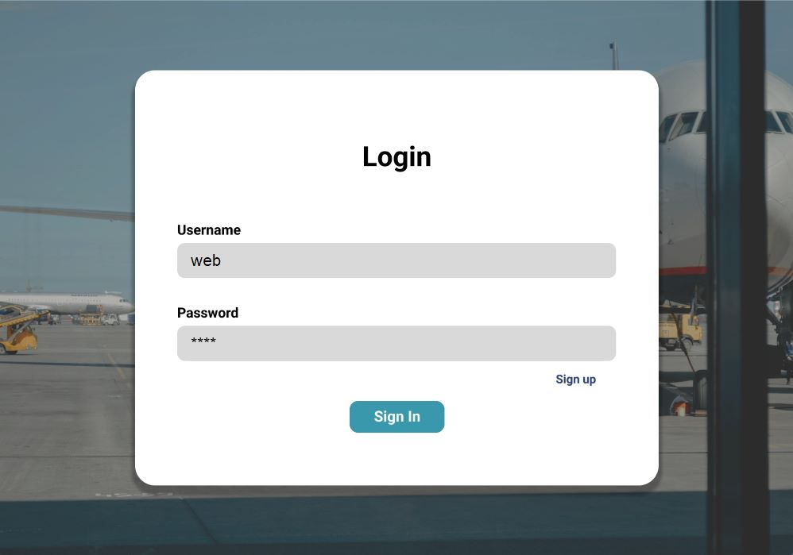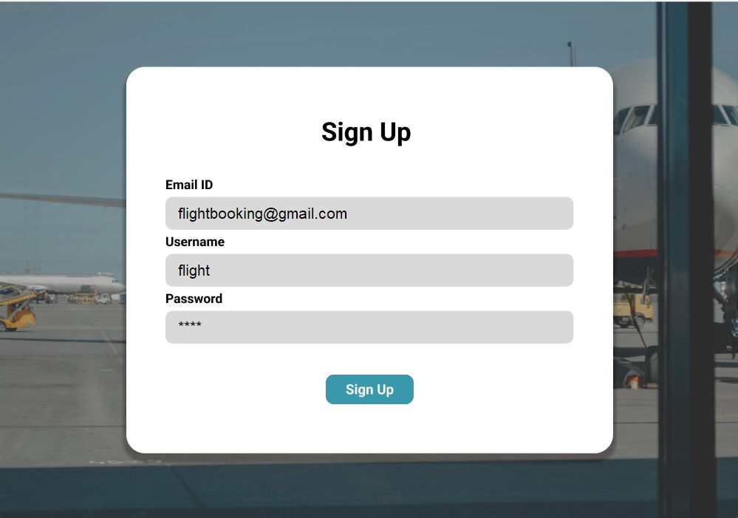

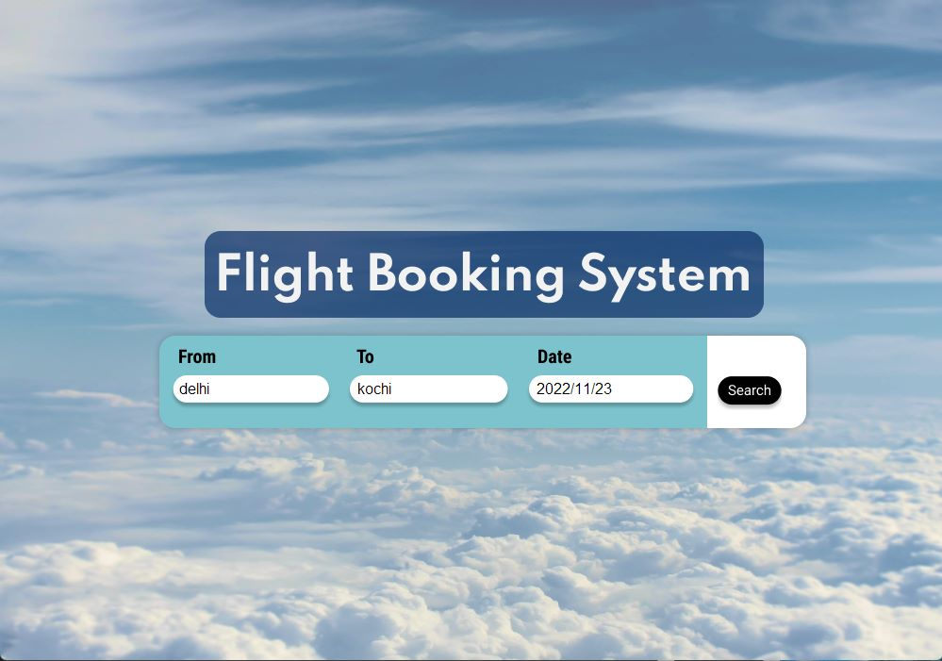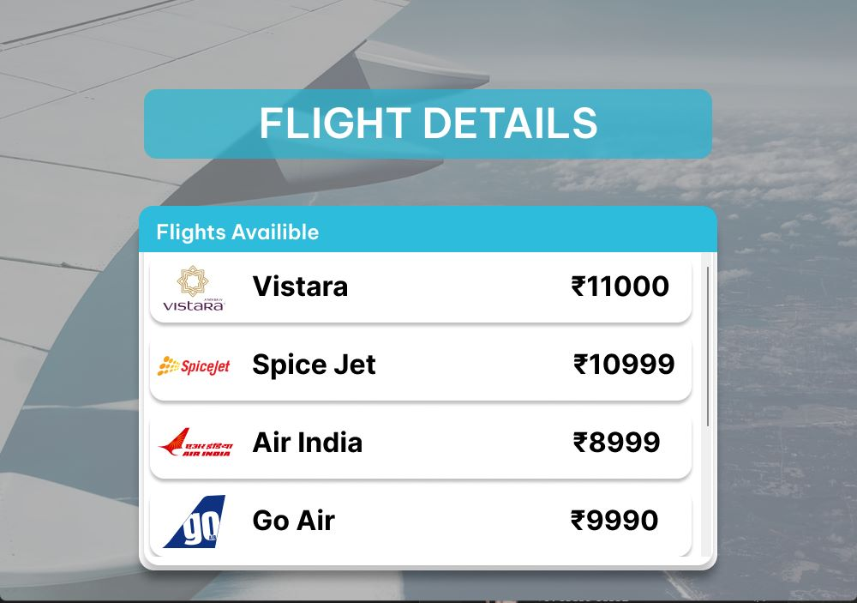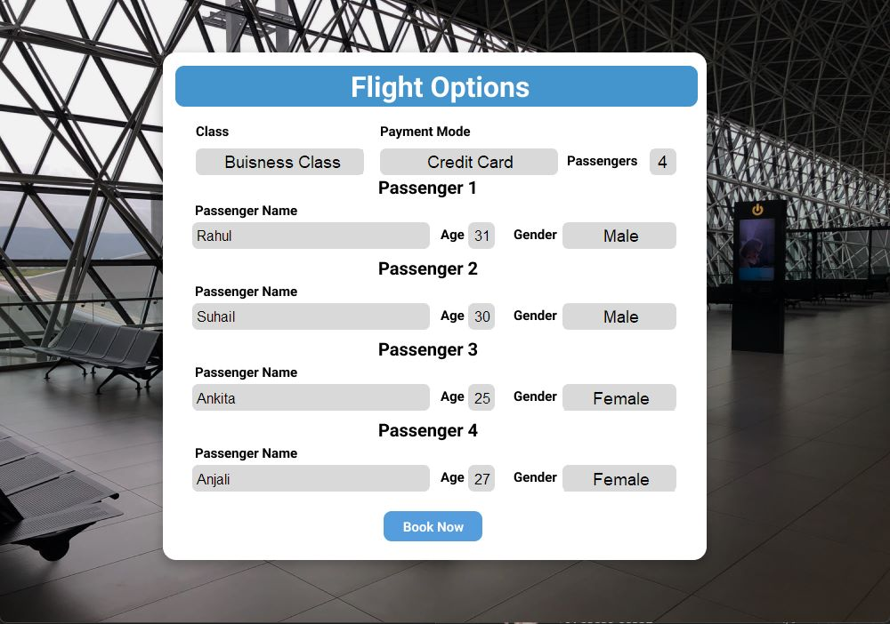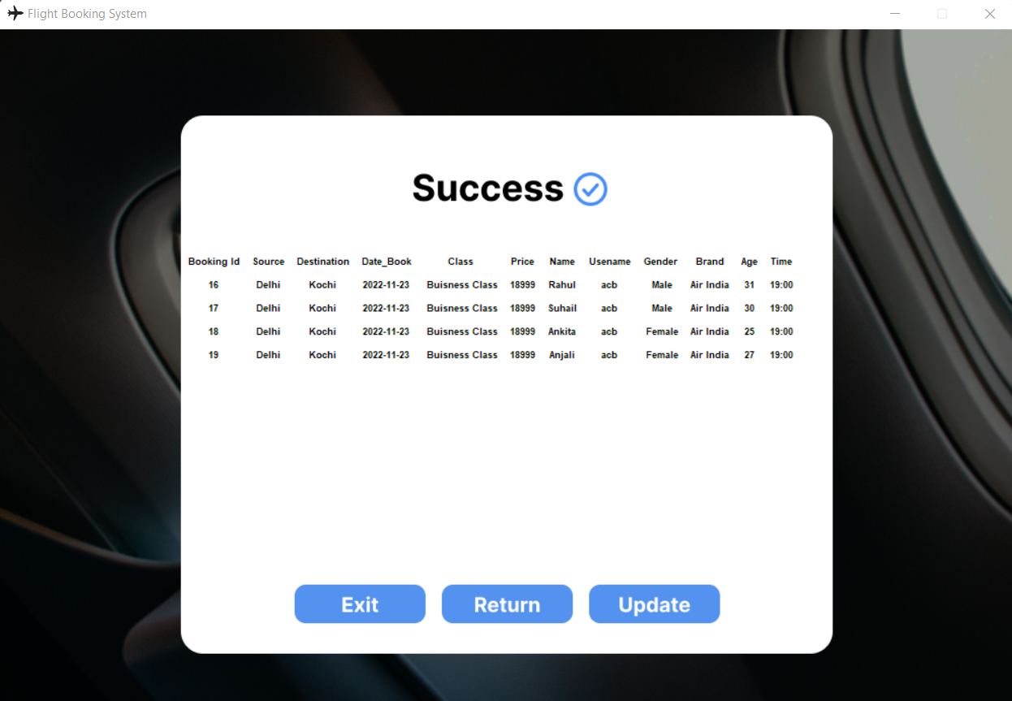

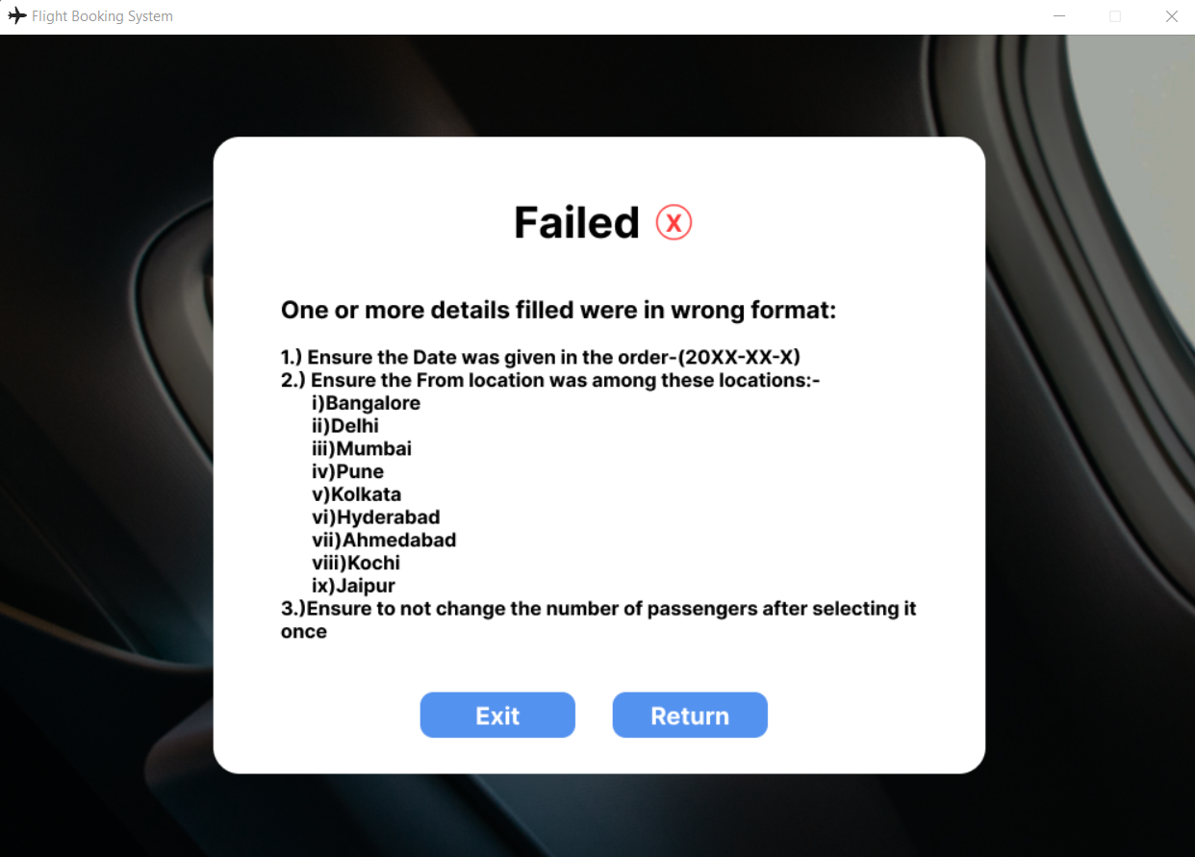

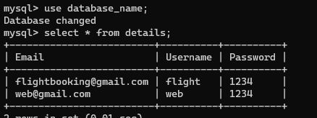

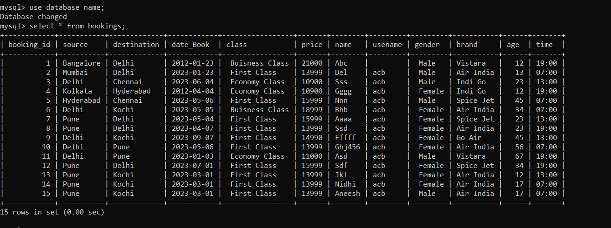

**AREA OF DEVELOPEMENT**

Our project is a simple GUI based flight booking system which integrates mysql, python and tkinter .

It makes use of basic modules and functions to generate a interactive platform where a user can view flight details for preferred location. Further he can book a flight and the details for the same will be displayed after successful booking.

But our project lacks some other features that we would like to add in future to improvise our prototype:

1. TCL commands: Used for transactions. This will enable to carry out transactions.
2. Complex Database management system: With the use of complex databases we can integrate data at different levels to make our data more organised and accessible.
3. Better GUI: By acquiring further knowledge on GUI infrastructure we can definitely improve the overall interface making it more appealing and user-friendly.

**BIBLIOGRAPHY**

1. W3schools
2. Geeksforgeeks
3. Github.com
4. www.tutorialspoint.com